“LOOK 16 AT 60’s”
“The greatest misconception of weight loss and getting fitter is that age is a stumbling block. It never is, being fit is within everyone’s reach”, One of the articles from Pune mirror, Anil Kapoor said.
“Family time has always been important for me to unwind and help think positively. Being healthy includes a stress-free attitude and the most underrated aspects of all sleep”.
“One has to understand that results will come once you approach 3 things the right way diet, exercise and sleep”.
Adopting a healthy lifestyle free from intoxication, reading about athletes and their endurance, learning about mindsets, good work ethics and good habits from achievers in other fields is great motivator as well”.
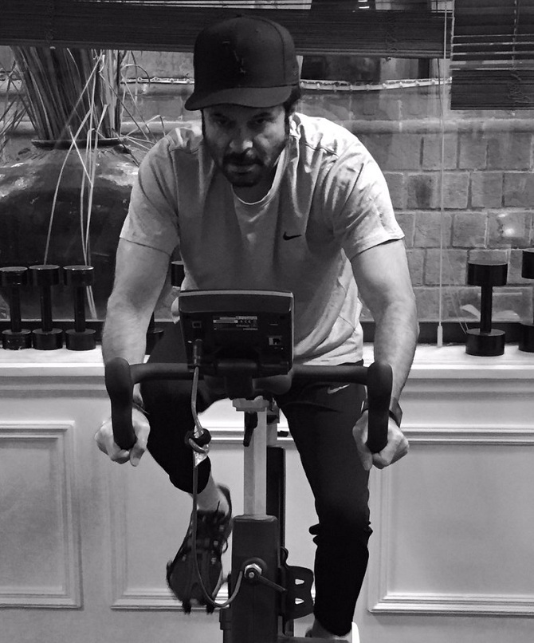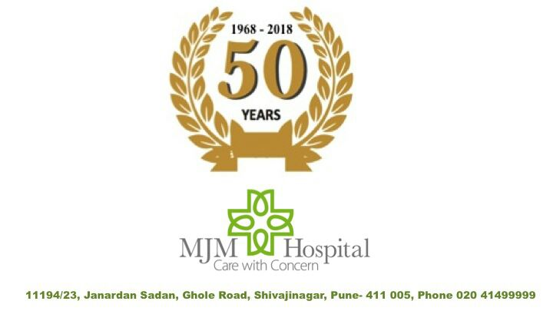
MJM HOSPITAL runs “LIFESTYLE DISEASE CLINIC” in their hospital at Ghole road, Pune. The hospital is instrumental in solving lifestyle problems of patients.
For more details contact: 09769337236

